Paul Collado
Exam 01

FrmColladoEx01

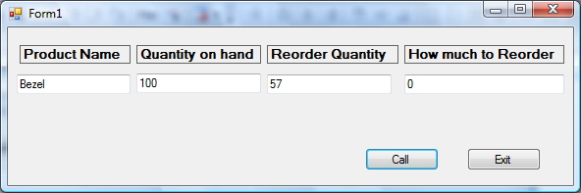
Public Class FrmColladoEx01

Private Sub BtnExit_Click(ByVal sender As System.Object, ByVal e As System.EventArgs) Handles BtnExit.Click
Me.Close()
End Sub

Private Sub BtnCall_Click(ByVal sender As System.Object, ByVal e As System.EventArgs) Handles BtnCall.Click
Dim Qty As Integer
Dim Pname As String = ""

input(Pname, Qty)
Display(Pname, Qty)

End Sub
Public Sub input(ByRef Pname As String, ByRef Qty As Integer)
Pname = InputBox("Enter product name", "Input Name")
Qty = Val(InputBox("Please enter Quantity", "Input Qty"))
End Sub
Private Sub Display(ByRef PName As String, ByRef Qty As Integer)
Dim RQ As Integer
Me.TxtName1.Text = PName
Me.TxtQty1.Text = Qty
RQ = Reorder(PName, Qty)
Me.TxtReorder1.Text = RQ

End Sub
Function Reorder(ByRef PName As String, ByRef Qty As Integer) As Integer
If PName = "Bezel" Then
Me.TxtRQ1.Text = 57
If Qty > 57 Then
Reorder = 0
Else
Reorder = 57 - Qty
End If
End If
If PName = "Bezel Bracket" Then
Me.TxtRQ1.Text = 75
If Qty > 75 Then
Reorder = 0
Else
Reorder = 75 - Qty
End If
End If
If PName = "Tape" Then
Me.TxtRQ1.Text = 45
If Qty > 45 Then
Reorder = 0
Else
Reorder = 45 - Qty
End If
End If

End Function
End Class

